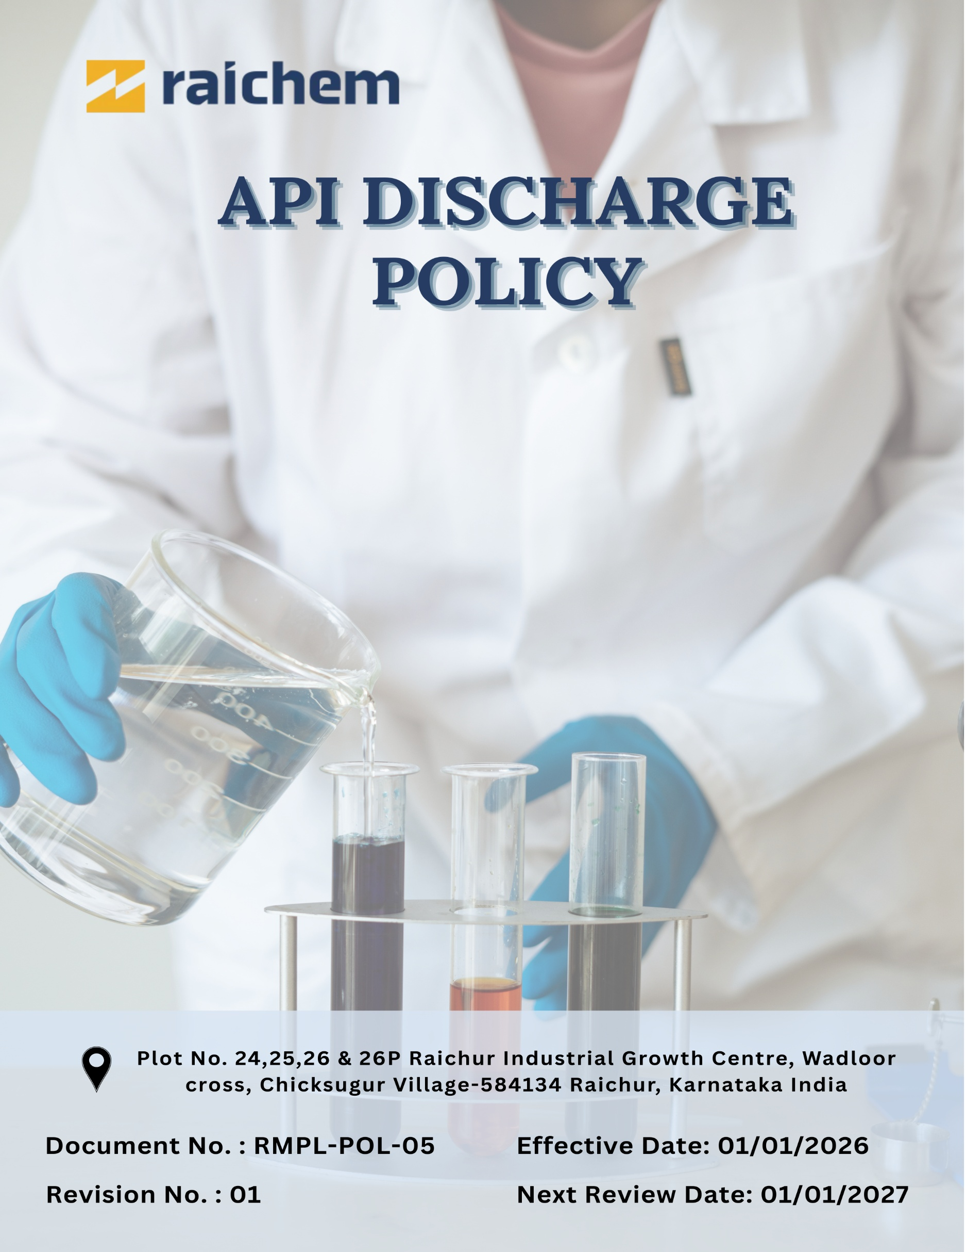
Contents

Preface 3
Policy Declaration 3
Scope 4
Strategic Environmental Objectives 4
Quantitative Performance Targets 4
Alignment with the United Nations Sustainable Development Goals (SDGs) 5
Responsibilities 5
Monitoring, Reporting and Transparency 6
Review Mechanism 6
Employee Acknowledgment Form 7

API DISCHARGE POLICY

Preface
Pharmaceutical manufacturing processes may generate wastewater streams containing trace quantities of Active Pharmaceutical Ingredients (APIs), intermediates, solvents, and process residues. If not effectively controlled, such discharges contribute to environmental contamination and impact aquatic ecosystems.
Raichem Medicare Pvt. Ltd. recognizes the importance of responsible effluent management as part of its commitment to sustainable pharmaceutical production. The company operates manufacturing facilities dedicated to the production of bile acid derivatives and Ursodeoxycholic Acid (UDCA) APIs and therefore acknowledges the need for strict control of pharmaceutical residues in wastewater streams.
To ensure environmental protection, Raichem Medicare Pvt. Ltd. operates under a Zero Liquid Discharge (ZLD) framework, where all wastewater generated from operations is treated, recovered, and reused within the facility, eliminating any discharge of liquid effluent into the external environment.
This policy establishes the principles and management framework for minimizing API residues through effective process control, advanced wastewater treatment systems, monitoring programs, and responsible operational practices aligned with ZLD requirements.

Policy Declaration
Raichem Medicare Pvt. Ltd. is committed to responsible wastewater management through the implementation of a Zero Liquid Discharge (ZLD) system, ensuring that no untreated or treated wastewater is discharged outside the facility.
The company adopts engineering controls, advanced treatment technologies, and operational practices to recover, recycle, and reuse treated water within its operations. Continuous improvement in wastewater management is achieved through process optimization, technological upgrades, and regular monitoring to ensure environmentally responsible and regulatory-compliant pharmaceutical manufacturing.

Scope
This policy applies to all Raichem operations that generate wastewater containing APIs or related residues. It covers manufacturing, utilities, and environmental management, as well as contractors involved in effluent treatment, recycling, monitoring, and disposal processes under the Zero Liquid Discharge (ZLD) system

Site | Address
Raichem Medicare Pvt. Ltd. | Plot No. 24,25,26 & 26P Raichur Industrial Growth Centre, Wadloor cross, Chicksugur Village 584134 Raichur, Karnataka, India

Strategic Environmental Objectives
Raichem Medicare Pvt. Ltd. aims to achieve the following environmental objectives with respect to API discharge management:
- Minimize API residues in wastewater through optimized production processes and containment measures.
- Ensure efficient operation of the Effluent Treatment Plant (ETP) system to effectively treat wastewater containing API residues and facilitate safe recovery and reuse of treated water within the facility.
- Implement robust monitoring and analytical programs to detect and control pharmaceutical residues in all wastewater streams.
- Maintain Zero Liquid Discharge (ZLD) to ensure that wastewater containing Active Pharmaceutical Ingredient (API) residues is fully treated, recovered, and reused within the facility without releasing liquid effluent into the external environment.

Quantitative Performance Targets
To strengthen environmental performance related to wastewater management, Raichem Medicare Pvt. Ltd. has established the following targets, with FY 2023–24 considered as the baseline year, and achievement planned by FY 2029–30.
- Achieve 25% reduction in API residues in wastewater streams entering the treatment system through improved process efficiency, solvent recovery practices, and optimized effluent treatment operations by FY 2029–30.
- Maintain 100% treatment and internal reuse of wastewater under the Zero Liquid Discharge system, supported by continuous monitoring and periodic analytical verification by FY 2029–30.
- Increase operational efficiency of the Effluent Treatment Plant (ETP) by 50% through periodic process audits and technical upgrades, where required till FY 2029-30.

Alignment with the United Nations Sustainable Development Goals (SDGs)
The sustainability objectives and performance targets align with the following Sustainable Development Goals (SDGs):
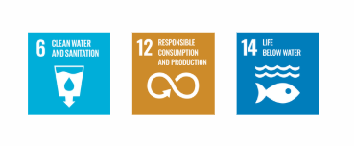

Responsibilities
- Senior Management: Approve the policy and ensure resources for effective operation of the ETP and ZLD systems.
- Environment, Health and Safety (EHS) Department: Implement the policy, monitor wastewater and API residues, and ensure regulatory compliance.
- ETP / ZLD Team: Operate and maintain the treatment and ZLD system to ensure proper treatment and reuse of wastewater.
- Production and Utilities Departments: Implement process controls to minimize API residues in wastewater and ensure proper handling of effluents.
- Employees and Contractors: Follow wastewater management procedures and report any abnormal discharge or incidents.

Monitoring, Reporting and Transparency

Raichem Medicare Pvt. Ltd. conducts regular monitoring of wastewater generated from its manufacturing operations. Key parameters such as pH, COD, BOD, and TDS are analyzed to assess treatment efficiency and system performance.
Wastewater is treated through the Effluent Treatment Plant (ETP) and Zero Liquid Discharge (ZLD) system, where treated water is recovered and reused within the facility, ensuring no liquid discharge outside the site.
Monitoring results are reviewed by the EHS team and reported to management to support regulatory compliance and continuous environmental improvement.

Review Mechanism
This API Discharge Policy will be reviewed annually by the EHS Manager of Raichem Medicare Pvt. Ltd. to ensure its continued relevance, effectiveness, and alignment with applicable environmental regulations, industry best practices, and the company’s operational requirements. The review will be carried out in consultation with the Production, Utilities, and senior management teams. Any significant revisions to the policy will be approved by management and communicated to relevant employees and stakeholders.

Effective Date | : 01.01.2026
Next Review Date | : 01.01.2027
Revision No. | : 01

Approved By:

Employee Acknowledgment Form
I acknowledge that I have read and understood the API Discharge Policy of Raichem Medicare Pvt. Ltd. and the company’s commitment to responsible management of wastewater generated from its operations.
I understand the importance of controlling API residues in effluents through proper treatment, monitoring, and compliance with environmental regulations.
By signing this document, I confirm that I will comply with the requirements of this policy, carry out all responsibilities applicable to my role, and report any abnormal discharge or incident through the appropriate channels.

Employee Name | : _________________________
Employee ID | : _________________________
Department | : _________________________
Signature | : _________________________

